**Signal Propagation**

Both wired networks and wireless communication networks have senders and receivers of signals. In terms of signal propagation, these two networks exhibit considerable differences. In wireless networks, the signal has no wire to determine the direction of propagation, whereas signals in wired networks only travel along the wire (which can be twisted pair copper wires, a coax cable, and fiber etc.). As long as the wire is not interrupted or damaged, it typically exhibits the same characteristics at each point. One can precisely determine the behavior of a signal, travelling along this wire. For wireless transmission, this predictable behavior is only valid in a vacuum, i.e., without matter between the sender and the receiver. The situation would be as follows

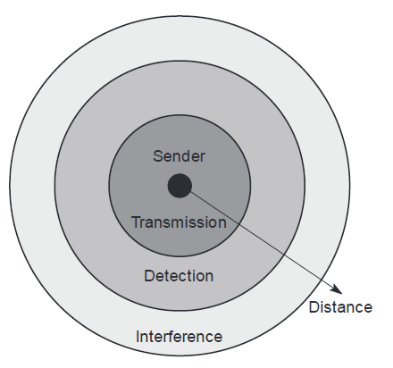

**Figure 1. Ranges for transmission, detection, and interference of signals**

● Transmission range: Within a certain radius of the sender transmission is possible, i.e., a receiver receives the signals with an error rate low enough to be able to communicate and can also act as sender.

● Detection range: Within this range detection of the transmission is possible, i.e., the transmitted power is large enough to differ from background noise. However, the error rate is too high to establish communication.

● Interference range: Within this range the sender may interfere with other transmission by adding to the background noise. A receiver will not be able to detect the signals, but the signals may disturb other signals.

This simple and ideal scheme led to the notion of cells around transmitters. However, real life does not happen in a vacuum, radio transmission has to contend with our atmosphere, mountains, buildings, moving senders and receivers etc. In reality, the three circles referred to above will be bizarrely-shaped polygons with their shape being time and frequency dependent.

**Cellular systems**

Cellular systems for mobile communications implement Space Division Multiplexing (SDM). Each transmitter, is called a base station and covers a certain area, referred to as a cell. Cell radii can vary from tens of meters in buildings, and hundreds of meters in cities, up to tens of kilometers in the countryside. The shape of cells are never perfect circles or hexagons (as shown in Figure 2.), but depend on the environment (buildings, mountains, valleys etc.), on weather conditions, and sometimes even on system load. Typical systems using this approach are mobile telecommunication systems, where a mobile station within the cell around a base station communicates with this base station and vice versa.

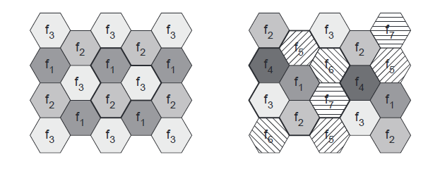

**Figure 2. Cellular system with three and seven cell clusters**

In this context, the question arises as to why mobile network providers install several thousands of base stations throughout a country (which is quite expensive) and do not use powerful transmitters with huge cells like, e.g., radio stations, use.

**Advantages of cellular systems with small cells:**

● Higher capacity: Implementing SDM allows frequency reuse. If one transmitter is far away from another, i.e., outside the interference range, it can reuse the same frequencies. As most mobile phone systems assign frequencies to certain users (or certain hopping patterns), this frequency is blocked for other users. But frequencies are a scarce resource and, the number of

concurrent users per cell is very limited. Huge cells do not allow for more users. On the contrary, they are limited to less possible users per Km2. This is also the reason for using very small cells in cities where many more people use mobile phones.

● Less transmission power: While power aspects are not a big problem for base stations, they are indeed problematic for mobile stations. A receiver far away from a base station would need much more transmit power than the current few Watts. But energy is a serious problem for mobile handheld devices.

● Local interference only: Having long distances between sender and receiver results in even more interference problems. With small cells, mobile stations and base stations only have to deal with ‘local’ interference.

● Robustness: Cellular systems are decentralized and so, more robust against the failure of single components. If one antenna fails, this only influences communication within a small area.

**Disadvantages of Small Cells:**

● Infrastructure needed: Cellular systems need a complex infrastructure to connect all base stations. This includes many antennas, switches for call forwarding, location registers to find a mobile station etc, which makes the whole system quite expensive.

● Handover needed: The mobile station has to perform a handover when changing from one cell to another. Depending on the cell size and the speed of movement, this can happen quite often.

● Frequency planning: To avoid interference between transmitters using the same frequencies, frequencies have to be distributed carefully. On the one hand, interference should be avoided, on the other, only a limited number of frequencies is available.

To avoid interference, different transmitters within each other’s interference range use FDM. If FDM is combined with TDM, the hopping pattern has to be coordinated. The general goal is never to use the same frequency at the same time within the interference range. Two possible models to create cell patterns with minimal interference are shown in Figure 2. Cells are combined in clusters – on the left side three cells form a cluster, on the right side seven cells form a cluster. All cells within a cluster use disjointed sets of frequencies. On the left side, one cell in the cluster uses set f1, another cell f2, and the third cell f3. In real-life transmission, the pattern will look somewhat different. The hexagonal pattern is chosen as a simple way of illustrating the model. This pattern also shows the repetition of the same frequency sets. The transmission power of a sender has to be limited to avoid interference with the next cell using the same frequencies.

To reduce interference even further sectorized antennas can be used. Figure 3. shows the use of three sectors per cell in a cluster with three cells. Typically, it makes sense to use sectorized antennas instead of Omni directional antennas for larger cell radii.

The fixed assignment of frequencies to cell clusters and cells respectively, is not very efficient

if traffic load varies. For instance, in the case of a heavy load in one cell and a light load in a neighboring cell, it could make sense to ‘borrow’ frequencies. Cells with more traffic are dynamically allotted more frequencies. This scheme is known as borrowing channel allocation (BCA), while the first fixed scheme is called fixed channel allocation (FCA). FCA is used in the GSM system as it is much simpler to use, but it requires careful traffic analysis before installation.

A dynamic channel allocation (DCA) scheme can also be implemented. In this scheme, frequencies can only be borrowed, but it is also possible to freely assign frequencies to cells. With dynamic assignment of frequencies to cells, the danger of interference with cells using the same frequency exists. The ‘borrowed’ frequency can be blocked in the surrounding cells.

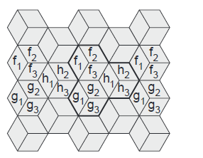

**Figure 3. Cellular system with three cell clusters and three sectors per cell**

Cellular systems using CDM instead of FDM do not need such elaborate channel allocation schemes and complex frequency planning. Here, users are separated through the code they use, not through the frequency. Cell planning faces another problem – the cell size depends on the current load. Accordingly, CDM cells are commonly said to ‘breathe’. While a cell can cover a larger area under a light load, it shrinks if the load increases. The reason for this is the growing noise level if more users are in a cell. (Remember, if you do not know the code, other signals appear as noise, as more and more people join the party.) The higher the noise, the higher the path loss and the higher the transmission errors. Finally, mobile stations further away from the base station drop out of the cell. Figure 4. illustrates this phenomenon with a user transmitting a high bit rate stream within a CDM cell. This additional user lets the cell shrink with the result that two users drop out of the cell. In a real-life scenario this additional user could request a video stream (high bit rate) while the others use standard voice communication (low bit rate).

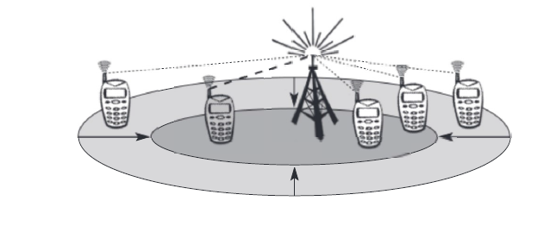

**Figure 4. Cell breathing depending on the current load**

**Multiplexing**

Multiplexing is not only a fundamental mechanism in communication systems but also in everyday life. Multiplexing describes how several users can share a medium with minimum or no interference.

**Space Division Multiplexing (SDM)**

For wireless communication, multiplexing can be carried out in four dimensions: space, time, frequency, and code. The task of multiplexing is to assign space, time, frequency, and code to each communication channel with a minimum of interference and a maximum of medium utilization. The term communication channel here only refers to an association of sender(s) and receiver(s) who want to exchange data.

Figure 5. shows six channels ki and introduces a three dimensional coordinate system. This system shows the dimensions of code c, time t, and frequency f. For SDM multiplexing), the (three dimensional) space si is also shown. Here space is represented via circles indicating the interference range as introduced in Figure 1, How is the separation of the different channels achieved? The channels k1 to k3 can be mapped onto the three ‘spaces’ s1 to s3 which clearly separate the channels and prevent the interference ranges from overlapping. The space between the interference ranges is sometimes called guard space. Such a guard space is needed in all four multiplexing techniques presented.

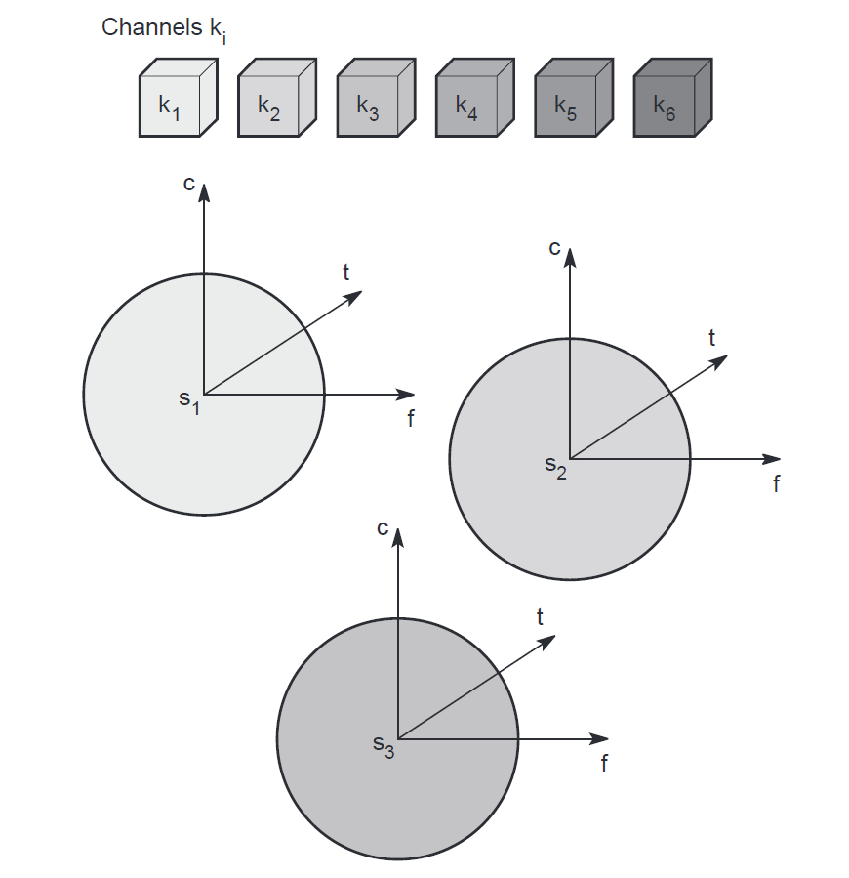

**Figure 4. Space Division multiplexing (SDM)**

For the remaining channels (k4 to k6) three additional spaces would be needed. Although this procedure clearly represents a waste of space, this is exactly the principle used by the old analog telephone system: each subscriber is given a separate pair of copper wires to the local exchange. In wireless transmission, SDM implies a separate sender for each communication channel with a wide enough distance between senders. This multiplexing scheme is used, for example, at FM radio stations where the transmission range is limited to a certain region where many radio stations around the world can use the same frequency without interference. Using SDM, obvious problems arise if two or more channels were established within the same space, for example, if several radio stations want to broadcast in the same city. Then, one of the following multiplexing schemes must be used (frequency, time, or code division multiplexing).

**Frequency Division Multiplexing (FDM)**

FDM describes schemes to subdivide the frequency dimension into several non-overlapping frequency bands as shown in Figure 5. Each channel ki is now allotted its own frequency band as indicated. Senders using a certain frequency band can use this band continuously. Again, guard spaces are needed to avoid frequency band overlapping (also called adjacent channel interference). This scheme is used for radio stations within the same region, where each radio station has its own frequency. This very simple multiplexing scheme does not need complex coordination between sender and receiver: the receiver only has to tune in to the specific sender.

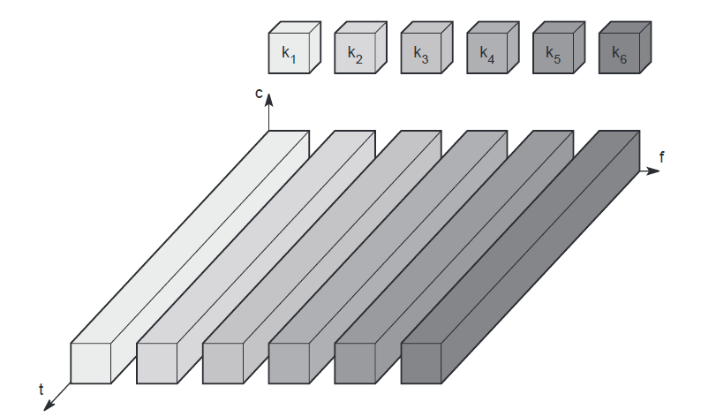

**Figure 5. Frequency Division Multiplexing (FDM)**

This scheme has disadvantages. While radio stations broadcast 24 hours a day, mobile communication typically takes place for only a few minutes at a time. Assigning a separate frequency for each possible communication scenario would be a tremendous waste of (scarce) frequency resources. Additionally, the fixed assignment of a frequency to a sender makes the scheme very inflexible and limits the number of senders.

**Time Division Multiplexing (TDM)**

A more flexible multiplexing scheme for typical mobile communications is TDM. Here a channel ki is given the whole bandwidth for a certain amount of time, i.e., all senders use the same frequency but at different points in time (see Figure 6.). Again, guard spaces, which now represent time gaps, have to separate the different periods when the senders use the medium. If two transmissions overlap in time, this is called co-channel interference. To avoid this type of interference, precise synchronization between different senders is necessary. This is clearly a disadvantage, as all senders need precise clocks or, alternatively, a way has to be found to distribute a synchronization sign al to all senders. For a receiver tuning in to a sender this does not just involve adjusting the frequency, but involves listening at exactly the right point in time. However, this scheme is quite flexible as one can assign more sending time to senders with a heavy load and less to those with a light load.

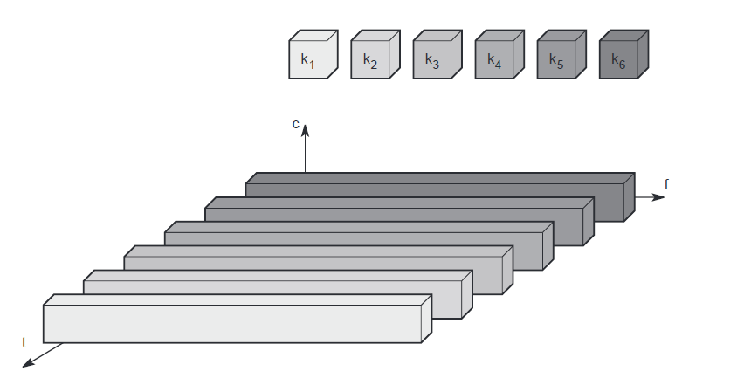

**Figure 6. Time Division Multiplexing (TDM)**

Frequency and time division multiplexing can be combined, i.e., a channel Ki can use a certain frequency band for a certain amount of time as shown in Figure 7. Now guard spaces are needed both in the time and in the frequency dimension. This scheme is more robust against frequency selective interference, i.e., interference in a certain small frequency band. A channel may use this band only for a short period of time. Additionally, this scheme provides some (weak) protection against tapping, as in this case the sequence of frequencies a sender, uses has to be known to listen in to a channel. The mobile phone standard GSM uses this combination of frequency and time division multiplexing for transmission between a mobile phone and a so-called base station.

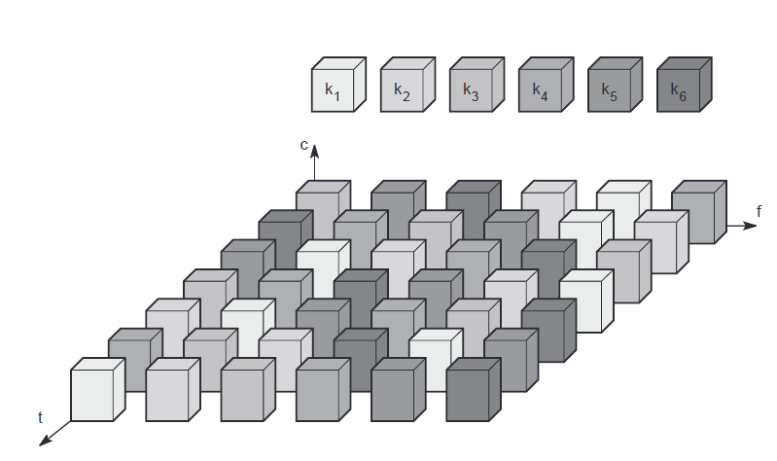

**Figure 7. Frequency and Time Division Multiplexing combine**

A disadvantage of this scheme is the necessary coordination between different senders. One has to control the sequence of frequencies and the time of changing to another frequency. Two senders will interfere as soon as they select the same frequency at the same time. However, if the frequency change (also called frequency hopping) is fast enough, the periods of interference may be so small that, depending on the coding of data into signals, a receiver can still recover the original data.

**Code Division Multiplexing (CDM)**

While SDM and FDM are well known from the early days of radio transmission and TDM is used in connection with many applications, CDM multiplexing is a relatively new scheme in commercial communication systems. It was first used in military applications due to its inherent security features (together with spread spectrum techniques), it now features in many civil wireless transmission scenarios, due to the availability of cheap processing power. Figure 8. shows how all channels ki use the same frequency at the same time for transmission. Separation is now achieved by assigning each channel its own ‘code’, guard spaces are realized by using codes with the necessary ‘distance’ in code space, e.g., orthogonal codes.

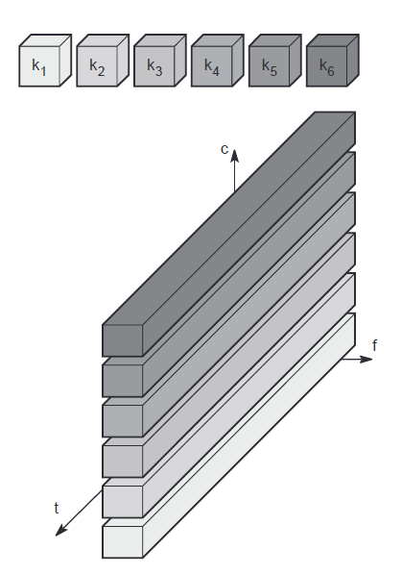

**Figure 8. Code Division Multiplexing (CDM)**

The main advantage of CDM for wireless transmission is that it gives good protection against interference and tapping. Different codes have to be assigned, but code space is huge compared to the frequency space. Assigning individual codes to each sender does not usually cause problems. The main disadvantage of this scheme is the relatively high complexity of the receiver. A receiver has to know the code and must separate the channel with user data from the background noise composed of other signals and environmental noise. Additionally, a receiver must be precisely synchronized with the transmitter to apply the decoding correctly. Another problem of CDM receivers is that all signals should reach a receiver with almost equal strength, otherwise some signals could drain others. To apply CDM, precise power control is required.

**Antennas**

Wireless communication involves ‘getting rid’ of wires and transmitting signals through space without guidance. We do not need any ‘medium’ (such as an Ethernet) for the transport of electromagnetic waves. We have to couple the energy from the transmitter to the out-side world and, in reverse, from the outside world to the receiver. This is exactly what antennas do. Antennas couple electromagnetic energy to and from space to and from a wire or coaxial cable (or any other appropriate conductor).

A theoretical reference antenna is the isotropic radiator, a point in space radiating equal power in all directions, i.e., all points with equal power are located on a sphere with the antenna as its center. The radiation pattern is symmetric in all directions (see Figure 9. a two dimensional cross-section of the real three-dimensional pattern).

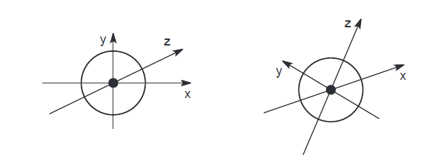

**Figure 9 Radiation pattern of an isotropic radiator**

However, such an antenna does not exist in reality. Real antennas all exhibit directive effects, i.e., the intensity of radiation is not the same in all directions from the antenna. The simplest real antenna is a thin, center-fed dipole, also called Hertzian dipole, as shown in Figure 10. (right-hand side). The dipole consists of two collinear conductors of equal length, separated by a small feeding gap. The length of the dipole is not arbitrary, but, for example, half the wavelength λ of the signal to transmit results in a very efficient, radiation of the energy. If mounted on the roof of a car, the length of λ/4 is efficient. This is also known as Marconi antenna.

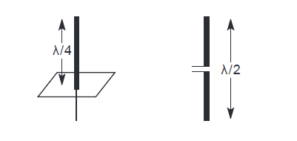

**Figure 10. Simple Antennas**

A λ/2 dipole has a uniform or Omni-directional radiation pattern in one plane and a figure eight pattern in the other two planes as shown in Figure 11. This type of antenna can only overcome environmental challenges by boosting the power level of the signal. Challenges could be mountains, valleys, buildings etc.

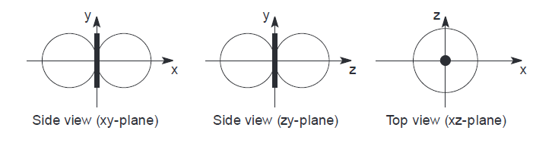

**Figure 11. Radiation pattern of a simple dipole**

If an antenna is positioned, e.g., in a valley or between buildings, an omnidirectional radiation pattern is not very useful. In this case, directional antennas with certain fixed preferential transmission and reception directions can be used. Figure 12. shows the radiation pattern of a directional antenna with the main lobe in the direction of the x-axis. A special example of directional antennas is constituted by satellite dishes.

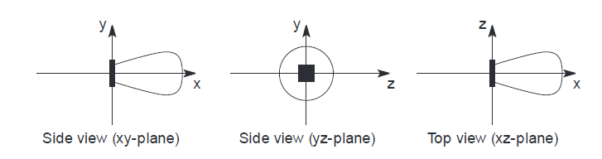

**Figure 12. Radiation pattern of a directed antenna**

Directed antennas are typically applied in cellular systems. Several directed antennas can be combined on a single pole to construct a sectorized antenna. A cell can be sectorized into, for example, three or six sectors, thus enabling frequency reuse as explained previously. Figure 13. shows the radiation patterns of these sectorized antennas.

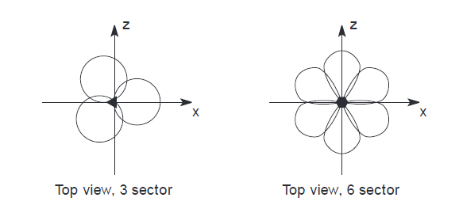

**Figure 13. Radiation patterns of sectorized antennas**

Two or more antennas can also be combined to improve reception by counteracting the negative effects of multi-path propagation. These antennas, also called multi-element antenna arrays, allow different diversity schemes. One such scheme is switched diversity or selection diversity, where the receiver always uses the antenna element with the largest output. Diversity combining constitutes a combination of the power of all signals to produce gain. The phase is first corrected (cophasing) to avoid cancellation. As shown in Figure 14, different schemes are possible. On the left, two λ/4 antennas are combined with a distance of λ/2 between them on top of a ground plane. On the right, three standard λ/2 dipoles are combined with a distance of λ/2 between them. Spacing could also be in multiples of λ/2.

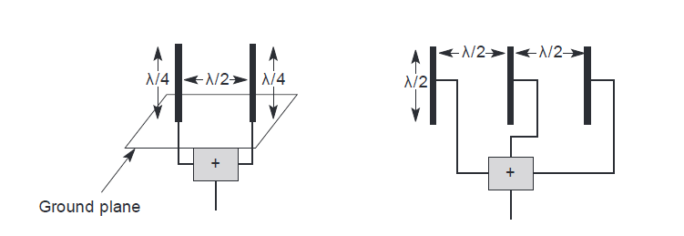

**Figure 14. Diversity antenna systems**

A more advanced solution is provided by smart antennas which combine multiple antenna elements (also called antenna array) with signal processing to optimize the radiation/reception pattern in response to the signal environment. These antennas can adapt to changes in reception power, transmission conditions and many signal propagation effects. Antenna arrays can also be used for beam forming. This would be an extreme case of a directed antenna which can follow a single user thus using space division multiplexing. It would not just be base stations that could follow users with an individual beam. Wireless devices, too, could direct their electromagnetic radiation, e.g., away from the human body towards a base station. This would help in reducing the absorbed radiation. Today’s handset antennas are Omni-directional as the integration of smart antennas into mobiles is difficult and has not yet been realized.